2022
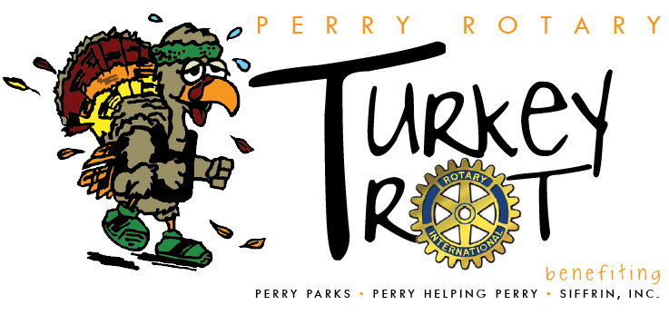
Perry Helping Perry * Meyers Lake YMCA * Light After Loss * The Legacy Project of Stark County
Sole Inspiration * Compassion Delivered * Whispering Grace Horses/Freedom Farms

MAJOR SPONSORSHIP $2,500 (Only 2 Available)
- Large Company Logo (color) on the event T-Shirt, given to each participant -LOCATION SELECTION on SHIRT
- Company Banner at the event at Start or Finish line
- Recognized on all event promotional materials and advertising
- Recognized on the Perry Rotary website for 1 year
- 4 Complimentary Run/Walk Participants
- Table at the event to display company information, optional
- Provide promotional materials to be given to each participant, optional
EVENT SPONSORS $1,000
- Large Company Logo (color) on the event T-Shirt, given to each participant
- Company Banner at the event
- Recognized on all event promotional materials and advertising
- Recognized on the Perry Rotary website for 1 year
- 2 Complimentary Run/Walk Participants
- Table at the event to display company information, optional
- Provide promotional materials to be given to each participant, optional
T-SHIRT SPONSORS $500
- Company logo (color) listed on the back of the event T-shirt, given to each participant
- Recognized on the Perry Rotary website for 1 year
- 1 Complimentary Run/Walk Participant
- Provide promotional materials to be given to each participant, optional
500 Meter Sign Sponsor $100
- Sign at a 500-meter mark on racecourse
- Provide promotional materials to be given to each participant, optional
________________________________________________________________________________________________________
Deadline: September 10, 2022
Company or Individual Name (as it appears on signage): _________________________________________
Contact: _________________________________________ Phone: _____________________________
Email: _______________________________________________________________________________
I want to be a(n):
_____ Major Sponsor ____ Event Sponsor ____ T-Shirt Sponsor ____ 500 Meter Sign Sponsor
Please make checks payable to: Perry Twp Rotary, and mail to: TURKEY TROT, PO Box 80371, Canton, OH 44708

